Exploring the postures with the breath: 26 January
During this practice,
- Move into postures on the exhalation
- Allow yourself to release and expand with a passive inhalation
In every posture,
- Feel your connection with the ground
- Sink your weight into the ground as you exhale
- Then the spine will naturally lengthen and release

What happens when we exhale? Among other things…
- The abdomen draws in towards the spine
- The lower back lengthens as the lumbar curve flattens
- The ribs relax downwards and inwards
- The upper back lengthens as the thoracic curve flattens
So we move into postures on the exhalation, as if riding a wave; the lengthening of the spine takes the body into the posture. The inhalation remains completely passive, a moment of expansion.
If we are practising continuous movements, eg moving up and down in cat pose/ swinging the arms in standing/ warming the shoulders/ rocking from side to side on the floor, breathe naturally.
Experiment with a deeper exhalation in any of the positions:
- Lying down, have a few deeper outbreaths, feeling the abdomen drawing gently back towards the spine. Feel the lower back lengthen as you exhale. The in-breath is light and easy. Practise for a few breaths and then return to normal breathing
- Standing up, the deeper exhalation supports the spine. Practise gently drawing the abdomen back towards the spine as you move into a standing balance such as tree or warrior.
- Practise the stronger outbreath as you lengthen to the side in a standing side bend or lengthen up and back in a gentle standing backbend. The in-breath is passive and spacious.
- In a standing forward bend the deeper outbreath may take you deeper in the pose. The release of the spine has a wave-like quality, the exhalation taking you deeper and the inhalation gently lifting you up.
- The same may be felt in a seated forward bend.
- The strong outbreath supports the spine in headstand and other more challenging postures.
After a few deeper breaths, breathe naturally.
Natural, instinctive breathing will tend to have different characteristics depending on the position our body is in and how much we are exerting ourselves. eg when we are lying down the abdomen is totally relaxed and we tend to breathe low; when we are on all fours the abdominal muscles support the spine and the breath is felt more in the chest. In child pose, the abdomen is pressed against the thighs so the movement of the breath is felt more in the back of the body. These variations can be an interesting focus for (respectful) observation!.

Viloma breathing: pausing on the exhalation
This is a breathing pattern where you introduce quiet pauses as you breathe out. You can pause once, twice or more. The pause isn’t about ‘holding your breath’ and there is no tension in it – rather, it’s a moment of stillness and calm. Like walking slowly down a hill and pausing occasionally to admire the view.
Inhale normally. At the top of the in-breath, pause for a moment, with a relaxed face and body. Breathe out a little, and pause. Breathe out a little more and pause. Breathe out all the way.
Breathe in fully and repeat. Do this for several breaths and then return to normal breathing.

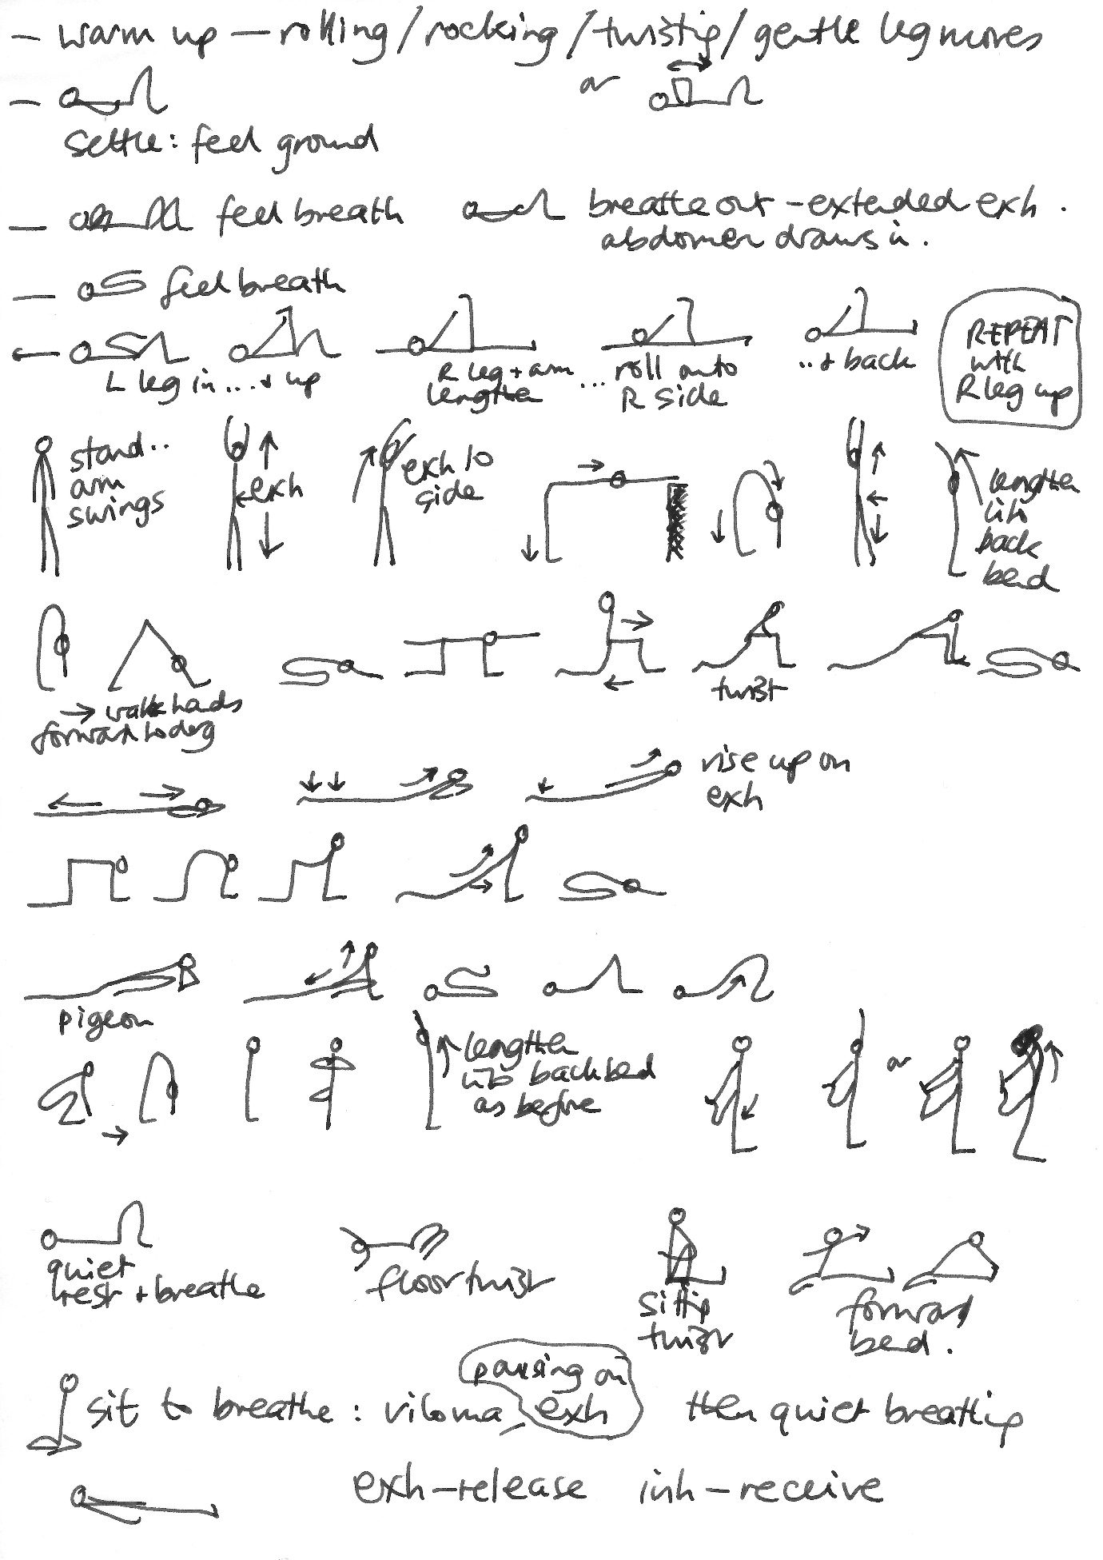
*exh = exhale; inh = inhale

